**ASSIGNMENT – 2:**

**NAME:**R.Maruthi

**REG NO:**192325055

**COURSE CODE:**CSA0678[DAA]

# 11. Container With Most Water

**You are given an integer array height of length n. There are n vertical lines drawn such that the two endpoints of the ith line are (i, 0) and (i, height[i]).**

**Find two lines that together with the x-axis form a container, such that the container contains the most water.**

**Return *the maximum amount of water a container can store*. Notice that you may not slant the container.**

**CODE:**

def maxArea(A, Len) :

area = 0 for i in range(Len) :

for j in range(i + 1, Len) :

area = max(area, min(A[j], A[i]) * (j - i)) return area

a = [ 1, 5, 4, 3 ]

b = [ 3, 1, 2, 4, 5 ]

len1 = len(a) print(maxArea(a, len1)) len2 = len(b) print(maxArea(b,len2))

OUTPUT:

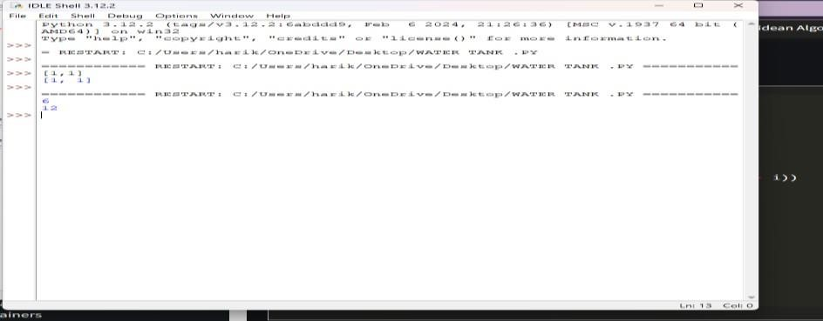

**12. Roman numerals are represented by seven different symbols: I, V, X, L, C, D and**

**M.**

**Symbol Value**

**I 1**

**V 5**

**X 10**

**L 50**

1. **100**
2. **500**

**M 1000**

**For example, 2 is written as II in Roman numeral, just two one's added together. 12 is written as**

**XII, which is simply X + II. The number 27 is written as XXVII, which is XX + V + II. Roman numerals are usually written largest to smallest from left to right. However, the numeral**

**for four is not IIII. Instead, the number four is written as IV. Because the one is before the five**

**we subtract it making four. The same principle applies to the number nine, which is written as**

**IX. There are six instances where subtraction is used:**

* **I can be placed before V (5) and X (10) to make 4 and 9.**
* **X can be placed before L (50) and C (100) to make 40 and 90.** ● **C can be placed before D (500) and M (1000) to make 400 and 900. Given an integer, convert it to a roman numeral.**

**CODE:**

def value(r): if (r == 'I'): return 1

if (r == 'V'):

return 5

if (r =='X'):

return 10

if (r == 'L'): return 50

if (r =='C'): return 100 if (r == 'D'): return 500 if (r =='M'): return 1000

else:

return -1 def romanToDecimal(str):

res = 0 i = 0 while (i < len(str)): # Getting value of symbol s[i] s1 = value(str[i]) if (i + 1 < len(str)): # Getting value of symbol s[i + 1] s2 = value(str[i + 1]) # Comparing both values if (s1 >= s2):

res = res + s1

i = i + 1

else:

res = res + s2 - s1 i = i + 2

else: res = res + s1 i = i + 1

return res

print("Integer form of Roman Numeral is"), print(romanToDecimal("MCMIV")) OUTPUT:

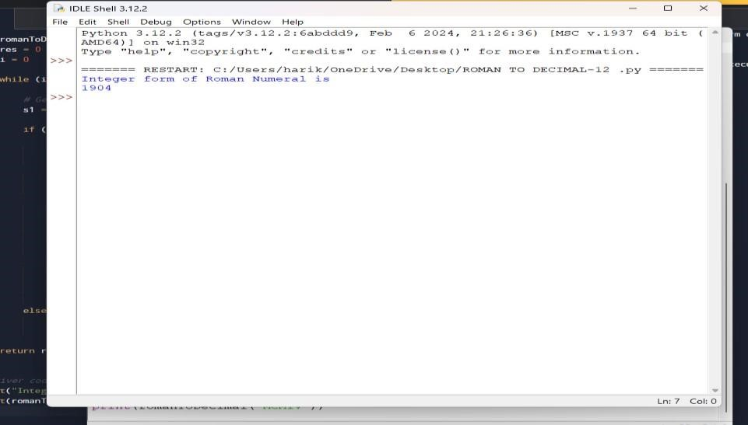

# 13. Roman to Integer

**Roman numerals are represented by seven different symbols: I, V, X, L, C, D and M.**

**Symbol Value**

**I 1**

**V 5**

**X 10**

**L 50**

1. **100**
2. **500**

**M 1000**

**For example, 2 is written as II in Roman numeral, just two ones added together. 12 is written as**

**XII, which is simply X + II. The number 27 is written as XXVII, which is XX + V + II. Roman numerals are usually written largest to smallest from left to right. However, the numeral**

**for four is not IIII. Instead, the number four is written as IV. Because the one is before the five**

**we subtract it making four. The same principle applies to the number nine, which is written as**

**IX. There are six instances where subtraction is used:**

* **I can be placed before V (5) and X (10) to make 4 and 9.**
* **X can be placed before L (50) and C (100) to make 40 and 90.**
* **C can be placed before D (500) and M (1000) to make 400 and 900.**

**Code:**

roman = {'I':1,'V':5,'X':10,'L':50,'C':100,'D':500,'M':1000} class Solution: def romanToInt(self, S: str) -> int:

summ= 0

for i in range(len(S)-1,-1,-1):

num = roman[S[i]] if 3*num < summ: summ = summ-num else:

summ = summ+num

return sum

OUTPUT:

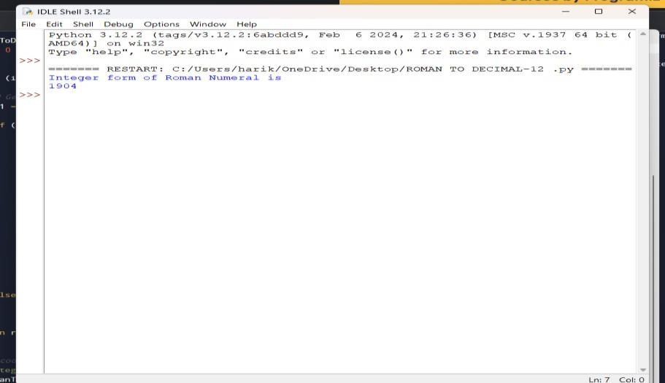

**14. Longest Common Prefix**

**Write a function to find the longest common prefix string amongst an array of strings. If there is no common prefix, return an empty string ""**

**CODE:**

def longestCommonPrefix( a): size = len(a)

if (size == 0):

return ""

if (size == 1):

return a[0]

min(len(a[0]), len(a[size - 1]))

i = 0 while (i < end and a[0][i] == a[size - 1][i]): i += 1

pre = a[0][0: i] return pre

if name == " main ":

input = ["geeksforgeeks", "geeks",

"geek", "geezer"]

print("The longest Common Prefix is :" , longestCommonPrefix(inp)

OUTPUT:

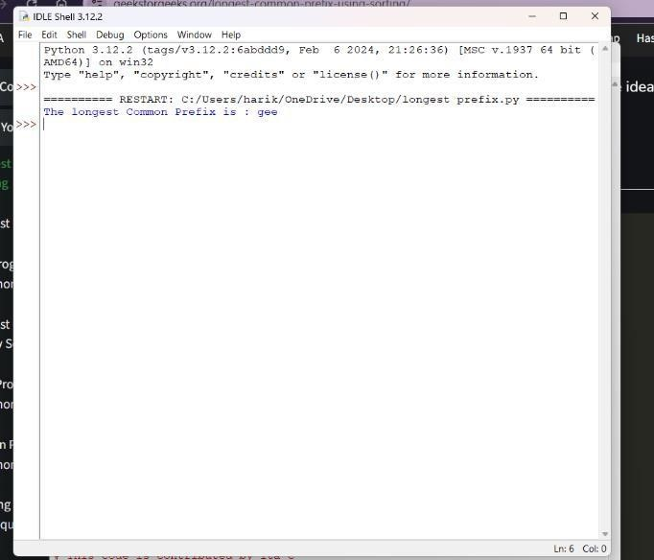

**15. 3Sum**

**Given an integer array nums, return all the triplets [nums[i], nums[j], nums[k]] such that i != j, i**

**!= k, and j != k, and nums[i] + nums[j] + nums[k] == 0. Notice that the solution set must not contain duplicate triplets.**

**Example 1:**

**Input: nums = [-1,0,1,2,-1,-4]**

**Output: [[-1,-1,2],[-1,0,1]] Explanation:**

**nums[0] + nums[1] + nums[2] = (-1) + 0 + 1 = 0. nums[1] + nums[2] + nums[4] = 0 + 1 + (-1) = 0. nums[0] + nums[3] + nums[4] = (-1) + 2 + (-1) = 0.**

**The distinct triplets are [-1,0,1] and [-1,-1,2].**

**Notice that the order of the output and the order of the triplets does not matter.**

**CODE:** def findTriplets(nums, n, Sum):

i = 0 j = 0 k = 0

. triplet = []

uniqTriplets = []

temp = ""

newTriplet = [0, 0, 0]

array. nums.sort()

for i in range(n - 2):

j = i + 1 # index of the last element. k = n - 1

while(j < k):

if(nums[i] + nums[j] + nums[k] == Sum):

temp = str(nums[i]) + ":" + str(nums[j]) + ":" + str(nums[k]) if temp not in uniqTriplets: uniqTriplets.append(temp) newTriplet[0] = nums[i] newTriplet[1] = nums[j] newTriplet[2] = nums[k] triplet.append(newTriplet) newTriplet = [0, 0, 0]

j += 1 k -= 1

elif(nums[i] + nums[j] + nums[k] > Sum): k-= 1

else:

j += 1

if(len(triplet) == 0): return 0

for i in range(len(triplet)): print(triplet[i], end = ", ") return 1

nums = [12, 3, 6, 1, 6, 9] n = len(nums) Sum = 24

if(not findTriplets(nums, n, Sum)): print("No triplets can be formed.") output:

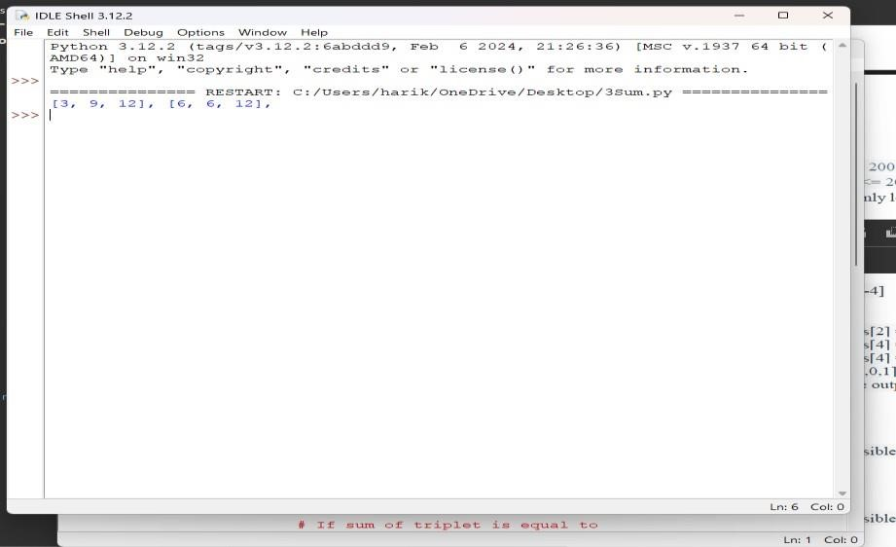

# 16. 3Sum Closest

**Given an integer array nums of length n and an integer target, find three integers in nums such that the sum is closest to target.**

**Return *the sum of the three integers*.**

**You may assume that each input would have exactly one solution.**

**CODE:**

import sys

def solution(arr, x):

closestSum = sys.maxsize

for i in range (len(arr)) :

for j in range(i + 1, len(arr)): for k in range(j + 1, len( arr)):

if(abs(x - closestSum) > abs(x - (arr[i] + arr[j] + arr[k]))): closestSum = (arr[i] + arr[j] + arr[k])

return closestSum

if name == " main ":

arr = [ -1, 2, 1, -4 ]

x = 1

print(solution(arr,x))

**output:**

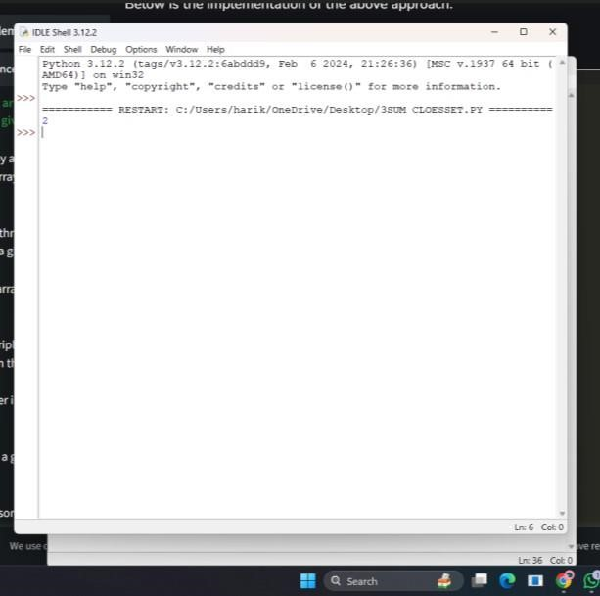

# 17. Letter Combinations of a Phone Number

**Given a string containing digits from 2-9 inclusive, return all possible letter combinations that the number could represent. Return the answer in any order.**

**A mapping of digits to letters (just like on the telephone buttons) is given below. Note that 1**

**does not map to any letters.**

CODE:

import deque

def letterCombinationsUtil(number, n, table):

list = [] q = deque()

q.append("")

while len(q) != 0:

s = q.pop()

len(s) == n:

list.append(s)

else:

for letter in table[number[len(s)]]:

q.append(s + letter)

return list

def letterCombinations(number, n):

ith digit in phone table = ["0", "1", "abc", "def", "ghi", "jkl","mno", "pqrs", "tuv", "wxyz"]

list = letterCombinationsUtil(number, n, table)

s = "" for word in list: s += word + " "

print(s) return

number = [2, 3] n = len(number)

letterCombinations(number, n)

OUTPUT:

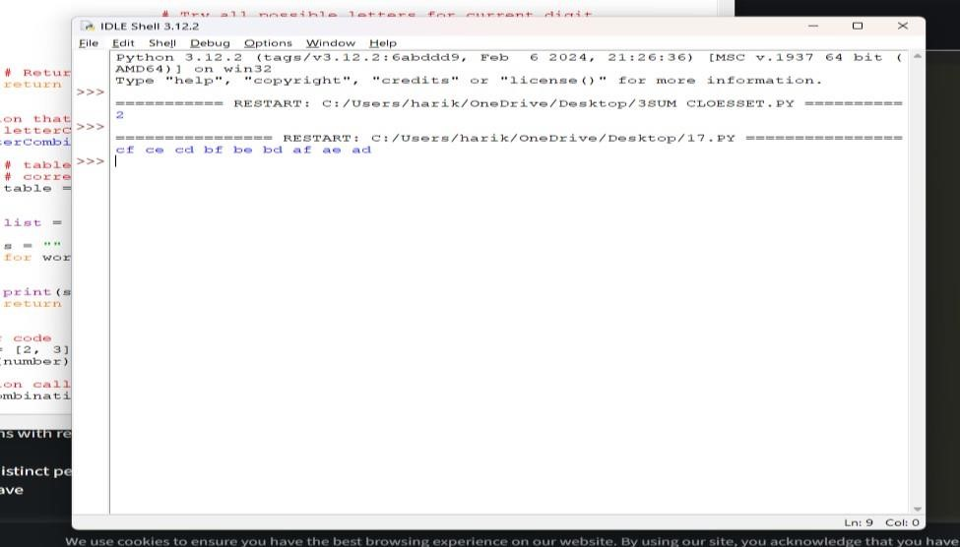

# 18. 4Sum

**Given an array nums of n integers, return *an array of all the unique quadruplets***

**[nums[a], nums[b], nums[c], nums[d]] such that:** ● **0 <= a, b, c, d < n**

* **a, b, c, and d are distinct.**
* **nums[a] + nums[b] + nums[c] + nums[d] == target**

**CODE:**

Pair:

def init (self, x, y):

self.index1 = x self.index2= y

def GetQuadruplets(nums, target):

map = {}

for the map for i in range(len(nums) - 1):

for j in range(i + 1, len(nums)): # Find the sum of pairs of elements sum = nums[i] + nums[j]

if sum not in map:

map[sum] = [Pair(i, j)]

else: map[sum].append(Pair(i, j))

ans = set()

for i in range(len(nums) - 1): for j in range(i + 1, len(nums)): lookUp = target - (nums[i] + nums[j])

if lookUp in map:

temp = map[lookUp]

for pair in temp:

if pair.index1 != i and pair.index1 != j and pair.index2 != i and pair.index2 != j: l1 = [nums[pair.index1], nums[pair.index2], nums[i], nums[j]]

l1.sort()

ans.add(tuple(l1))

print(*reversed(list(ans)), sep = '\n')

arr = [1, 0, -1, 0, -2, 2]

K = 0

GetQuadruplets(arr, K)

OUTPUT:

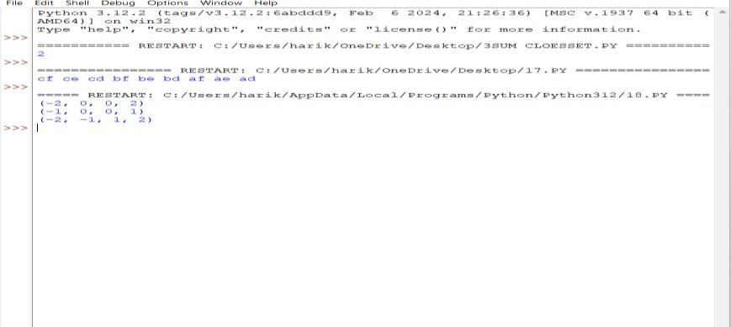

**19. Remove Nth Node From End of List**

**Given the head of a linked list, remove the nth node from the end of the list and return its head.**

**CODE:**

class Node:

def init (self, value):

self.data = value self.next = None def length(head): temp = head count = 0 while(temp != None): count += 1 temp = temp.next return count

def printList(head): ptr = head while(ptr != None): print (ptr.data, end =" ") ptr = ptr.next print()

def deleteNthNodeFromEnd(head, n): Length = length(head) nodeFromBeginning = Length - n + 1 prev = None temp = head for i in range(1, nodeFromBeginning):

prev = temp temp = temp.next if(prev == None): head = head.next return head else: prev.next = prev.next.next return head

if name == ' main ':

head = Node(1) head.next = Node(2) head.next.next = Node(3) head.next.next.next = Node(4) head.next.next.next.next = Node(5) print("Linked List before Deletion:") printList(head)

head = deleteNthNodeFromEnd(head, 4)

print("Linked List after Deletion:") printList(head)

OUTPUT:

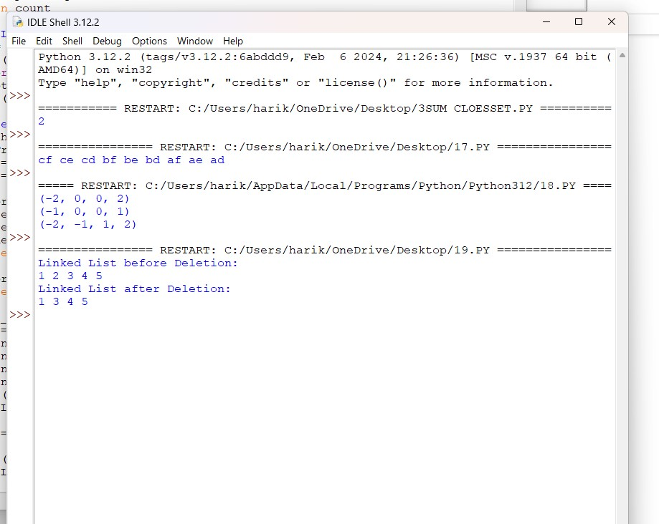

# 20. Valid Parentheses

**Given a string s containing just the characters '(', ')', '{', '}', '[' and ']', determine if the input string is valid.**

**An input string is valid if:**

1. **Open brackets must be closed by the same type of brackets.**
2. **Open brackets must be closed in the correct order.**
3. **Every close bracket has a corresponding open bracket of the same type.**

CODE: def areBracketsBalanced(expr): stack = []

For char in expr:

if char in ["(", "{", "["]: # Push the element in the stack stack.append(char) else:

if not stack:

return False

current_char = stack.pop() if current_char == '(':

if char != ")":

return False

if current_char == '{':

if char != "}":

return False

if current_char == '[':

if char != "]":

return False if stack:

return False return True

if name == " main ":

expr = "{()}[]"

if BracketsBalanced(expr): print("Balanced")

else:

print("Not Balanced")

OUTPUT:

